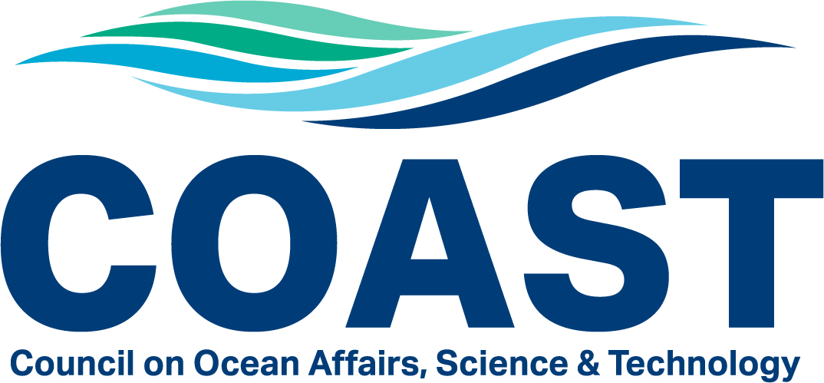
Undergraduate Student Research Award Program
2025-2026

Announcement

What: Funds are now available from CSU COAST to support undergraduate research projects.

Who: The program is available to undergraduate students enrolled at Cal Poly Humboldt and who propose an activity on a marine- or coastal-related subject. The student must be in good academic standing (GPA > 2.0) and work with a Cal Poly Humboldt COAST faculty advisor. Students are encouraged to submit joint applications when appropriate. A letter of recommendation from the faculty advisor is not required.

When Can I Apply: Proposals can be submitted anytime between January 15 and April 15, 2025. Upon submission we will review your proposal and make a decision within 10 working days. Funds can be used over the summer.

How Much: Up to $500 may be requested for supplies, software, fees. Larger requests (up to $750) may be considered under certain circumstances (see below).

How to Apply: Read the FAQs below, fill out the application form, and follow the instructions for submission. Incomplete applications will not be evaluated.

Direct questions to Dr. Christine Cass: cjc695@humboldt.edu
CSU COAST - CAL POLY HUMBOLDT
Undergraduate Student Research Award Program

Frequently Asked Questions

- What is the goal of this funding opportunity?
To support undergraduate students interested in marine-related careers and provide them with the opportunity to obtain the skills necessary to join a highly skilled, technologically advanced workforce in the marine sciences.
- What are the eligibility requirements to apply for a grant?
Students must be enrolled at Cal Poly Humboldt and propose an activity on a marine-related subject. The students must be in good academic standing (GPA > 2.0) and work with a Cal Poly Humboldt COAST faculty advisor. A letter of recommendation from the faculty advisor is not required.
- What does it take to be a Cal Poly Humboldt COAST faculty?
Faculty can be instructors, research associates, post-docs or on tenure-track at Cal Poly Humboldt. COAST is open to anyone in the CSU with an interest in marine and coastal affairs.
- What types of projects are supported by this opportunity?
The scope of topics that can be supported include:
- The open and coastal ocean;
- Coastal zones (bays, estuaries, beaches);
- Coastal watersheds to the extent that the organism, material or process ultimately articulates with the coast (e.g., anadromous fish, surface and groundwater flow and water quality, land use, etc.).
- What budget items are supported by this opportunity?
The standard request limit for these funds is $500. However, requests up to $750 which result in longer-term benefits to the marine facilities (e.g., shared equipment) will be considered. Examples of supported research-related expenses include, but are not limited to:
- Research supplies or materials (some personal field gear is allowed, although requests for only field gear should go through the COAST Program linked below);
- Rentals fees for boats, SCUBA or other specialized equipment;
- Sample analysis costs;
- Purchase of specialized software or equipment to analyze samples or data, including socioeconomic data.
NOTE: At this time we cannot support requests for gas or mileage reimbursement or travel to meetings or workshops. Requests for wages or tuition are also not supported.
If you are looking for funding to cover personal field gear or conference travel, we recommend applying to the COAST Field Experiences Support Program or COAST Student Travel Award Program, respectively.
- When do funds have to be used?
Funds can be used to support activities occurring between January 15 and Aug. 31, 2026. The funds must be spent or encumbered by Aug. 31, 2026.
- What should I write for the project description?
The project description should describe the research or activity you propose to conduct in a clear and concise statement and address how the project will help you achieve your career goals. The description should describe the context for the activity, the hypotheses to be tested (if any), and the methodology to be used in the study. Projects can involve more than one student, but one student should be designated as the proposal point person and take the lead in proposal submission, reporting, etc. Faculty input is strongly encouraged but the description should be written by the student. If the project is to take place at the Telonicher Marine Lab, you should consult the Marine Lab Project Request Form to ensure you consider appropriate logistics.
- How will projects be evaluated?
Proposals will be evaluated based on the importance of the research, the likelihood of project completion, the impact on student success, and the need for support. Those who have not received prior funding, or funding from other sources, are given priority.



Undergraduate Student Research Award
AY 2025-2026 Application Form
Application Deadline: Anytime between Jan. 15 and Apr. 15, 2026

Instructions: read the student research award FAQ before completing
- Complete this form and save this file as LastName_FirstName_COAST_Year.doc;
- Include a copy of your CV/Resume;
- Email both as an attachment to Dr. Christine Cass (cjc695@humboldt.edu) and also include your faculty advisor. Title your email “COAST Undergraduate Award Application”
Student Applicant Information
First Name: |  | Department or Degree Program:
Last Name: |  | GPA in Major Courses:
Student ID#: |  | Anticipated graduation date (mm/yy):
Area of interest: |  | Degree Sought (BA, BS, MS):
Email: |  | Phone:

Have you previously received a COAST Research Award? (Y/N)
If yes, please provide year of award and amount:

Faculty Advisor Information
First Name: |  | Email:
Last Name: |  | Phone:
Department:
Position/Title:

Research Project Title:

Is this project part of a specific course? If so, which course:

Project Description: Please describe the research or activity you propose to conduct in a clear and concise statement in the space provided and address how the project will help you achieve your career goals (do not change the typeface or size of font in this form). Faculty input is encouraged but the description should be written by the student. Proposals are rated based on the importance of research, likelihood of project completion, and impact on student success.

If you are planning a project at the Marine Lab, address whether you have consulted with ML staff about the feasibility of your project or completed the Project Request Form.

If you are planning a project which involves the use of small boats, please confirm that you have discussed your project with the boating safety officer.
_________________________________________________________________________________

*** Do not exceed this space ***
Brief summary of budget request (Up to $500 for a standard request). List and justify all budget requests.

If you wish to request $750, be sure to justify your extra budget by explaining how it will provide longer-term benefits to marine science research capacity at Cal Poly Humboldt .
___________________________________________________________________________________

Additional Support. Describe other sources of support you have for this project (if any):
___________________________________________________________________________________

